**Checklist Labo API**

1. **Get list**

|  |  |
| --- | --- |
| Method | Endpoint |
| POST | /api-checklist/v1/labo/list |

|  |  |  |
| --- | --- | --- |
| Params | Data type | Description |
| Code_Prov_T | String | To filter any record under province |
| Code_Dist_T | String | To filter any record under district |

|  |
| --- |
| Response as Json |
| [  {  "Rec_ID": 1,  "VisitDate": "2022-03-22",  "VisitorWorkplace": "PH",  "Code_Prov_T": "11",  "Code_Dist_T": "1105",  "HFName": "មន្ទីរពេទ្យបង្អែកខេត្ត មណ្ឌលគិរី",  "HFPhone": "០៨៨​៦៦៦៦៣៦៤",  "HFTelegram": "០៨៨​៦៦៦៦៣៦៤",  "LaboChief": "ឆាយ​ កក្កដា",  "LaboChiefTelegram": "០៣១ ៧៧៩៩៨២៦",  "HospitalChief": "វេជ្ជ ទុយ ស្រស់",  "HospitalChiefTelegram": "097 5566558",  "Interviewee": "យ៉ាន សុក្រិត",  "Interviewer": "ម៉ម មន្ថា"  }  ] |

1. **Get detail**

|  |  |
| --- | --- |
| Method | Endpoint |
| POST | /api-checklist/v1/labo/detail |

|  |  |
| --- | --- |
| Params | Data type |
| Rec_ID | int |

|  |
| --- |
| Response as Json |
| {  "Rec_ID": 1,  "VisitDate": "2022-03-22",  "VisitorWorkplace": "PH",  "Code_Prov_T": "11",  "Code_Dist_T": "1105",  "HFName": "មន្ទីរពេទ្យបង្អែកខេត្ត មណ្ឌលគិរី",  "HFPhone": "០៨៨​៦៦៦៦៣៦៤",  "HFTelegram": "០៨៨​៦៦៦៦៣៦៤",  "LaboChief": "ឆាយ​ កក្កដា",  "LaboChiefTelegram": "០៣១ ៧៧៩៩៨២៦",  "HospitalChief": "វេជ្ជ ទុយ ស្រស់",  "HospitalChiefTelegram": "097 5566558",  "Interviewee": "យ៉ាន សុក្រិត",  "Interviewer": "ម៉ម មន្ថា",  "MissionNo": "123ABC",  "Participants": [  {  "name": "តារ",  "position": "សិករ"  },  {  "name": "នារី",  "position": "កសិករ"  }  ],  "Detail": {  "P2Q1": { "answer": "Yes", "note": "ក" },  "P2Q2": { "answer": "No", "note": "ក" },  "P2Q3": { "answer": "Yes", "note": "ក" },  "P2Q4": [  { "microscope": "ក1", "month": "ក", "basis": "ក", "refresher": "ក", "evaluation": "ក", "note": "ក" },  { "microscope": "ក2", "month": "ក", "basis": "ក", "refresher": "ក", "evaluation": "ក", "note": "ក" },  { "microscope": "ក3", "month": "ក", "basis": "ក", "refresher": "ក", "evaluation": "ក", "note": "ក" },  { "microscope": "ក4", "month": "ក", "basis": "ក", "refresher": "ក", "evaluation": "ក", "note": "ក" },  { "microscope": "ក5", "month": "ក", "basis": "ក", "refresher": "ក", "evaluation": "ក", "note": "ក" },  ],  "P3Q1": { "answer": "Yes", "note": "" },  .  .  .  "P4_1Q1": { "answer": "Yes", "note": "" },  "P4_1Q2": { "answer": "Yes", "note": "" },  .  .  .  "P4_2Q4": { "answer": "Yes", "note": "", "useColor": true, "other": "" },  .  .  .  "P4_4Q5": { "answer": "តិចជាង១", "note": "" },  "P4_4Q6": { "answer": "តិចជាង១", "note": "" },  .  .  .  "P5_1Q1": { "answer": "100", "note": "" },  "P5_1Q2": { "answer": "100", "note": "" },  .  .  .  "P5_2Q1": {  "answer": ["5កញ្ចក់", "3កញ្ចក់", "1កញ្ចក់", "4កញ្ចក់", "2កញ្ចក់"]  },  "P5_2Q2": {  "answer": ["100", "100", "100", "100", "100"]  },  "P5_2Q3": {  "answer": ["0", "0", "0", "0", "0"]  },  "P5_2Q4": {  "answer": ["0", "0", "0", "0", "0"]  },  "P5_2Q5": {  "answer": ["100", "100", "100", "100", "100"]  },  "P5_2Q6": { "answer": "Yes", "note": "" },  "P6Q1": { "answer": "Yes", "note": "" },  .  .  .  "P10Q6": { "answer": "Yes", "note": "" },  "ProblemSolution": "ការប្រើប្រាស់សម្ភារៈផ្សេងៗក្នុងផ្នែកមន្ទីរពិសោធន៍\n\nចំនួនកញ្ចក់ឈាមវិជ្ជមាន"  }  } |

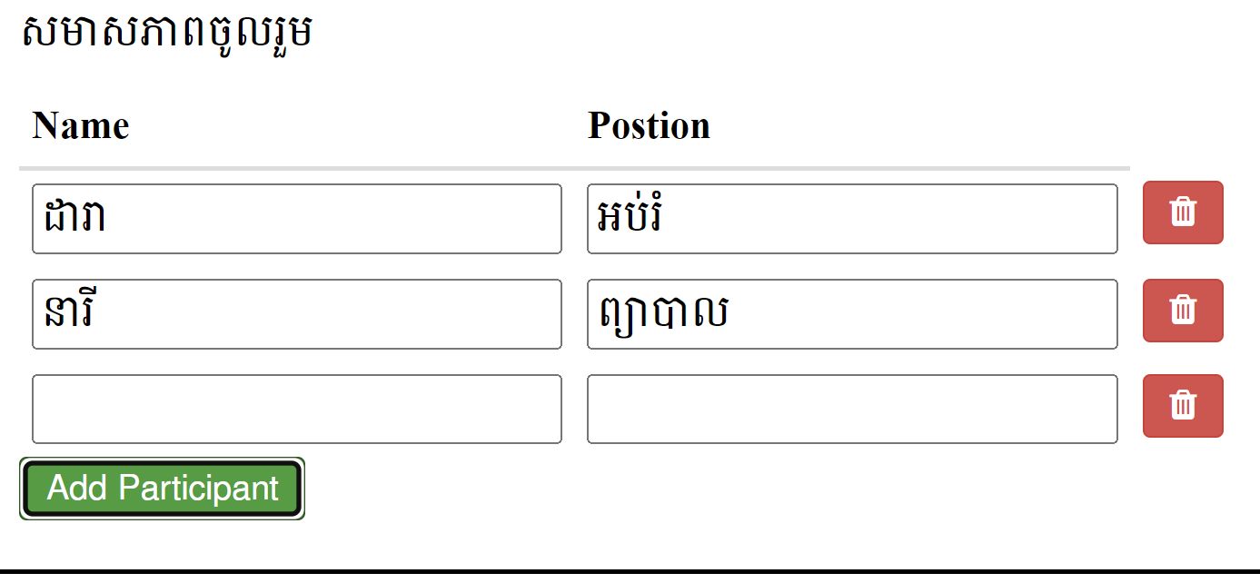

1. **Insert data & Update data**

|  |  |
| --- | --- |
| Method | Endpoint |
| POST | /api-checklist/v1/labo/update |

|  |
| --- |
| Object |
| {  "Rec_ID": 0 or 123, (0 for insert, number for update)  "VisitDate": "2022-03-22",  "VisitorWorkplace": "PH",  "Code_Prov_T": "11",  "Code_Dist_T": "1105",  "HFName": "មន្ទីរពេទ្យបង្អែកខេត្ត មណ្ឌលគិរី",  "HFPhone": "០៨៨​៦៦៦៦៣៦៤",  "HFTelegram": "០៨៨​៦៦៦៦៣៦៤",  "LaboChief": "ឆាយ​ កក្កដា",  "LaboChiefTelegram": "០៣១ ៧៧៩៩៨២៦",  "HospitalChief": "វេជ្ជ ទុយ ស្រស់",  "HospitalChiefTelegram": "097 5566558",  "Interviewee": "យ៉ាន សុក្រិត",  "Interviewer": "ម៉ម មន្ថា",  "MissionNo": "123ABC",  "Participants": [  {  "name": "តារ",  "position": "សិករ"  },  {  "name": "នារី",  "position": "កសិករ"  }  ],  "Detail": {  "P2Q1": { "answer": "Yes", "note": "ក" },  "P2Q2": { "answer": "No", "note": "ក" },  "P2Q3": { "answer": "Yes", "note": "ក" },  "P2Q4": [  { "microscope": "ក1", "month": "ក", "basis": "ក", "refresher": "ក", "evaluation": "ក", "note": "ក" },  { "microscope": "ក2", "month": "ក", "basis": "ក", "refresher": "ក", "evaluation": "ក", "note": "ក" },  { "microscope": "ក3", "month": "ក", "basis": "ក", "refresher": "ក", "evaluation": "ក", "note": "ក" },  { "microscope": "ក4", "month": "ក", "basis": "ក", "refresher": "ក", "evaluation": "ក", "note": "ក" },  { "microscope": "ក5", "month": "ក", "basis": "ក", "refresher": "ក", "evaluation": "ក", "note": "ក" },  ],  "P3Q1": { "answer": "Yes", "note": "" },  .  .  .  "P4_1Q1": { "answer": "Yes", "note": "" },  "P4_1Q2": { "answer": "Yes", "note": "" },  .  .  .  "P4_2Q4": { "answer": "Yes", "note": "", "useColor": true, "other": "" },  .  .  .  "P4_4Q5": { "answer": "តិចជាង១", "note": "" },  "P4_4Q6": { "answer": "តិចជាង១", "note": "" },  .  .  .  "P5_1Q1": { "answer": "100", "note": "" },  "P5_1Q2": { "answer": "100", "note": "" },  .  .  .  "P5_2Q1": {  "answer": ["5កញ្ចក់", "3កញ្ចក់", "1កញ្ចក់", "4កញ្ចក់", "2កញ្ចក់"]  },  "P5_2Q2": {  "answer": ["100", "100", "100", "100", "100"]  },  "P5_2Q3": {  "answer": ["0", "0", "0", "0", "0"]  },  "P5_2Q4": {  "answer": ["0", "0", "0", "0", "0"]  },  "P5_2Q5": {  "answer": ["100", "100", "100", "100", "100"]  },  "P5_2Q6": { "answer": "Yes", "note": "" },  "P6Q1": { "answer": "Yes", "note": "" },  .  .  .  "P10Q6": { "answer": "Yes", "note": "" },  "ProblemSolution": "ការប្រើប្រាស់សម្ភារៈផ្សេងៗក្នុងផ្នែកមន្ទីរពិសោធន៍\n\nចំនួនកញ្ចក់ឈាមវិជ្ជមាន"  }  } |

|  |
| --- |
| Response as Json (Insert data only) |
| { "Rec_ID": 1 } |

1. **Delete data**

|  |  |
| --- | --- |
| Method | Endpoint |
| POST | /api-checklist/v1/labo/delete |

|  |  |
| --- | --- |
| Params | Data type |
| Rec_ID | int |